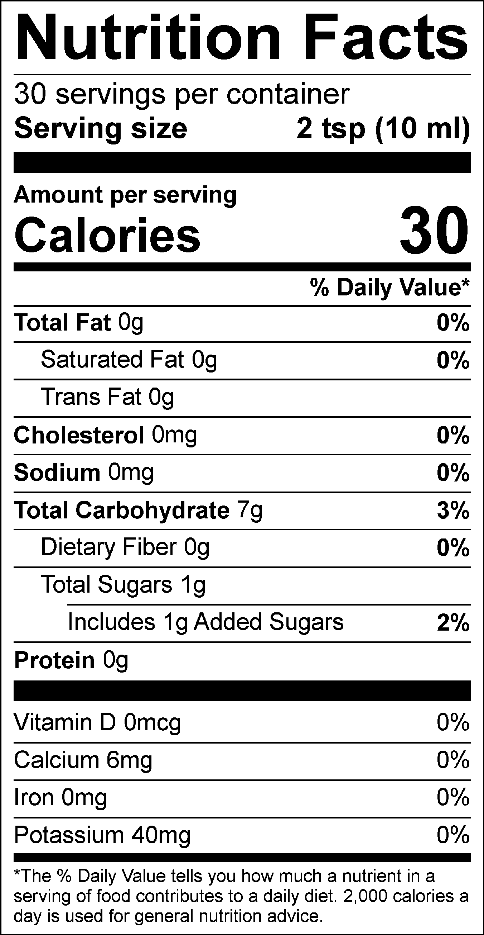

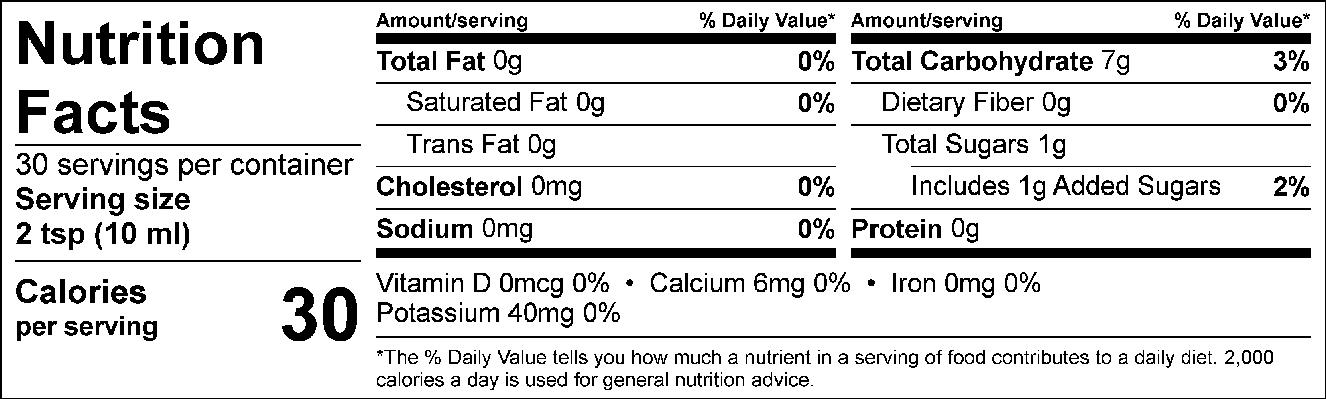

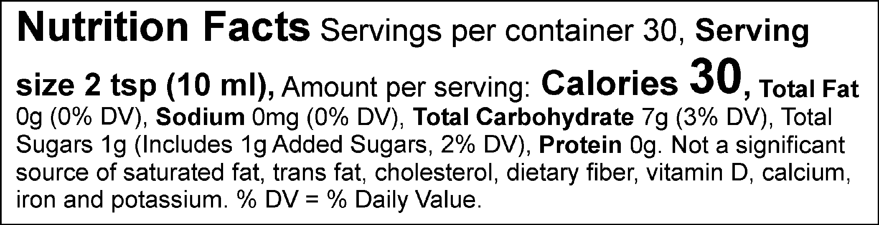

INGREDIENTS: Gastrodia Elata, Red Ginseng, Acanthopax, Korean Angelica Root, Jujube, Fructooligosaccharide

Red Ginseng Gastrodia